A GACD Implementation Science e-Hub Case Study
Strengthening Referral Networks for Management of Hypertension in Western Kenya

This case study was developed based on the work of
Strengthening Referral Networks for Management of Hypertension Across the Health System (STRENGTHS) study

Project team members
Aarti Thakkar, Thomas Valente, Josephine Andesia, Benson Njuguna, Juliet Miheso, Tim Mercer, Richard Mugo, Ann Mwangi, Eunice Mwangi, Sonak D. Pastakia, Shravani Pathak, Jemima Kamano, Violet Naanyu, Makeda Williams, Rajesh Vedanthan, Constantine Akwanalo, and Gerald S. Bloomfield.

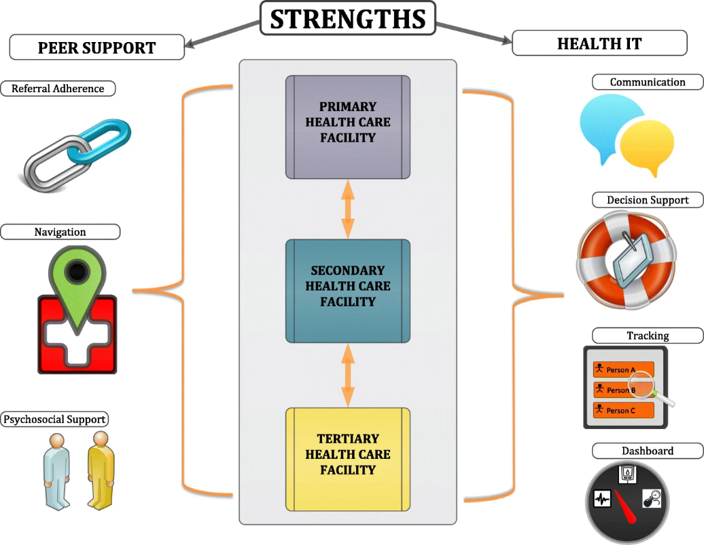
STRENGTHS intervention

Case study summary
The STRENGTHS (Strengthening Referral Networks for Management of Hypertension Across the Health System) study, based in Western Kenya, aims to revolutionize hypertension management and cardiovascular disease risk reduction. This pioneering project integrates health information technology (HIT) and peer support within a comprehensive referral network spanning primary to tertiary healthcare levels. Its primary objectives are to enhance referral efficacy, optimize blood pressure control, and improve cardiovascular health outcomes in resource-limited settings.


Identification and characterisation of implementation issues

Healthcare Challenge: High prevalence of hypertension in Kenya, underlined by significant treatment and control gaps in low-resource settings.

Systemic Issues: The challenges of a tiered healthcare system with inadequate referral networks impeding effective hypertension management.


Selection, adaptation, and application of implementation strategies
HIT Integration: Enhancing the AMPATH Medical Record System (AMRS) for data sharing, clinical decision support, patient tracking, and key referral process metrics.

Peer Support Initiative: Recruiting and training controlled hypertensive patients as peer navigators for referral adherence, health system navigation, and psychosocial support.

Development and delivery of the stakeholder engagement strategy
Collaborative Framework: Engaging a range of stakeholders, including healthcare providers, patients, community leaders, and international partners.
Community Involvement: Utilizing community assemblies (mabaraza) and focus groups to understand local perspectives and refine intervention strategies.


Evaluating implementation
Methodological Framework: Adoption of the PRECEDE-PROCEED model for multi-dimensional evaluation.
Baseline Assessment Methods: Implementing observational process mapping, referral network analysis, and qualitative research for in-depth baseline assessment.


Results and key findings
Clinical Outcomes: Marked improvement in systolic blood pressure control and reduction in overall cardiovascular risk.
Referral Process Improvement: Enhanced efficiency and effectiveness in referral completion, facilitated by the integrated HIT system.


Strengths and limitations
Strengths: Groundbreaking integration of technology with community engagement, comprehensive stakeholder involvement, and flexible adaptation to local healthcare contexts.

Limitations: Challenges in technology infrastructure across diverse regions, dependence on sustained community participation, and scalability of the model.

Success factors and challenges
Success Factors: Effective utilization of HIT, robust community engagement, and a transdisciplinary research approach.
Challenges: Addressing socioeconomic barriers to healthcare, ensuring consistent technology operation in rural areas, and integrating interventions within existing healthcare structures.


Next steps
Expansion and Policy Integration: Opportunities for scaling the model to other regions and diseases, and advocating for the integration of successful strategies into national health policies.
Long-Term Sustainability Focus: Emphasizing the integration of the project into Kenya's national healthcare system for enduring impact.

References
Thakkar, A., Valente, T., Andesia, J., Njuguna, B., Miheso, J., Mercer, T., Mugo, R., Mwangi, A., Mwangi, E., Pastakia, S. D., Pathak, S., Pillsbury, M. K. M., Kamano, J., Naanyu, V., Williams, M., Vedanthan, R., Akwanalo, C., & Bloomfield, G. S. (2022). Network characteristics of a referral system for patients with hypertension in Western Kenya: results from the Strengthening Referral Networks for Management of Hypertension Across the Health System (STRENGTHS) study. BMC health services research, 22(1), 315. https://doi.org/10.1186/s12913-022-07699-8
Akwanalo, C., Njuguna, B., Mercer, T., Pastakia, S. D., Mwangi, A., Dick, J., Dickhaus, J., Andesia, J., Bloomfield, G. S., Valente, T., Kibachio, J., Pillsbury, M., Pathak, S., Thakkar, A., Vedanthan, R., Kamano, J., & Naanyu, V. (2019). Strategies for Effective Stakeholder Engagement in Strengthening Referral Networks for Management of Hypertension Across Health Systems in Kenya. Global heart, 14(2), 173–179. https://doi.org/10.1016/j.gheart.2019.06.003
Pillsbury, M. K. M., Mwangi, E., Andesia, J., Njuguna, B., Bloomfield, G. S., Chepchumba, A., Kamano, J., Mercer, T., Miheso, J., Pastakia, S. D., Pathak, S., Thakkar, A., Naanyu, V., Akwanalo, C., & Vedanthan, R. (2021). Human-centered implementation research: a new approach to develop and evaluate implementation strategies for strengthening referral networks for hypertension in western Kenya. BMC health services research, 21(1), 910. https://doi.org/10.1186/s12913-021-06930-2
Mercer, T., Njuguna, B., Bloomfield, G. S., Dick, J., Finkelstein, E., Kamano, J., Mwangi, A., Naanyu, V., Pastakia, S. D., Valente, T. W., Vedanthan, R., & Akwanalo, C. (2019). Strengthening Referral Networks for Management of Hypertension Across the Health System (STRENGTHS) in western Kenya: a study protocol of a cluster randomized trial. Trials, 20(1), 554. https://doi.org/10.1186/s13063-019-3661-4

 Key learning objectives
- Understand how integrating HIT can improve hypertension management and enhance referral networks in low-resource settings.
- Recognise the importance of peer navigators in supporting patients and improving adherence to hypertension management strategies.
- Learn how engaging local communities and stakeholders through assemblies and focus groups can help tailor and refine healthcare interventions to better suit local contexts.

