A GACD Implementation Science e-Hub Case Study
A people-centred approach through Self-Management and Reciprocal learning for the prevention and management of Type 2 Diabetes

This case study was developed based on the work of
A people-centred approach through Self-Management and Reciprocal learning for the prevention and management of Type 2 Diabetes (SMART2D) study

Project team members
David Guwatudde, Pilvikki Absetz, Peter Delobelle, Claes-Göran Östenson, Josefien Van Olmen, Helle Molsted Alvesson, Roy William Mayega, Elizabeth Ekirapa Kiracho, Juliet Kiguli, Carl Johan Sundberg, David Sanders, Göran Tomson, Thandi Puoane, Stefan Peterson, Meena Daivadanam for the SMART2D Consortium

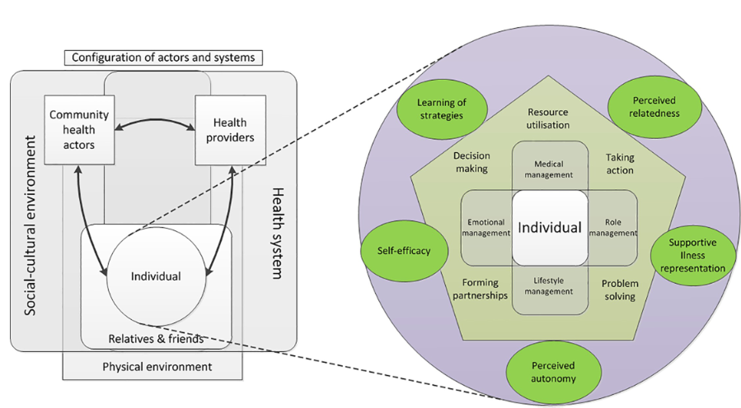
The SMART2D self-management framework

Case study summary
The people-centred approach through Self-Management and Reciprocal learning for the prevention and management of Type 2 Diabetes (SMART2D) project aimed to enhance Type 2 diabetes self-management across three diverse settings (Uganda, South Africa, and Sweden) using a reciprocal learning framework. This framework allowed for adaptations in community strategies like community mobilisation and peer support, critical to transferring and scaling up interventions.


Identification and characterisation of implementation issues
In different settings, specific barriers to effective diabetes management were identified: limited healthcare capacity in Uganda, environmental impacts on lifestyle in South Africa, and challenges in service access for immigrants in Sweden. These issues guided the development of context-specific interventions, focusing on enhancing patient roles and strengthening community-health facility linkages​.


Selection, adaptation, and application of implementation strategies
The intervention strategies were developed through a transdisciplinary framework that integrated evidence-based interventions with practical progress measures and participatory implementation processes. This strategic approach facilitated the adaptation of interventions like peer support groups and community health interventions, tailored to meet local needs while maintaining core objectives​.


Development and delivery of the stakeholder engagement strategy

Stakeholder engagement was integral, involving continuous interaction with local communities, health workers, and government bodies. This approach ensured that interventions were culturally sensitive and appropriately integrated into existing healthcare frameworks, thereby maximizing local buy-in and sustainability.

Evaluating implementation
The interventions were evaluated using a mix of quantitative and qualitative methods to assess both the process and the outcomes. This included monitoring intervention fidelity, participant engagement, and the impact on diabetes management, which revealed significant improvements in self-management among the target populations​.


Results and key findings
The project highlighted the effectiveness of community-linked models of care and peer support programs, significantly improving diabetes self-management. The findings emphasized the importance of contextually adapted interventions and the benefits of a strong focus on community engagement and education.


Strengths and limitations
A major strength was the project's ability to foster robust local and international collaborations, which enhanced the intervention's impact. However, a significant limitation was the variability in intervention implementation across sites, influenced by local contexts and available resources, which sometimes led to inconsistencies in delivery and outcomes.


Success factors and challenges
Key success factors included the adaptability of interventions to local contexts, effective stakeholder engagement, and strong leadership. Challenges were primarily related to maintaining consistency and meeting the diverse needs of each setting without diluting the effectiveness of the core intervention strategies.​


Next steps
For future projects, it is recommended to enhance strategies for engaging stakeholders and to continuously adapt interventions based on ongoing feedback and changing local conditions. Additionally, securing ongoing funding and government support remains crucial for the sustainability of such interventions.

References
Guwatudde D, Delobelle P, Absetz P, Van JO, Mayega RW, Kasujja FX, et al. Prevention and management of type 2 diabetes mellitus in Uganda and South Africa: Findings from the SMART2D pragmatic implementation trial. PLOS Global Public Health. 2022;2(5):e0000425.
van Olmen J, Absetz P, Mayega RW, Timm L, Delobelle P, Alvesson HM, et al. Process evaluation of a pragmatic implementation trial to support self-management for the prevention and management of type 2 diabetes in Uganda, South Africa and Sweden in the SMART2D project. BMJ open diabetes research & care. 2022;10(5).
Absetz P, Van Olmen J, Guwatudde D, Puoane T, Alvesson HM, Delobelle P, et al. SMART2D-development and contextualization of community strategies to support self-management in prevention and control of type 2 diabetes in Uganda, South Africa, and Sweden. Translational behavioral medicine. 2020;10(1):25-34.
David G, Pilvikki A, Peter D, Claes-Göran Ö, Josefien Olmen V, Helle Molsted A, et al. Study protocol for the SMART2D adaptive implementation trial: a cluster randomised trial comparing facility-only care with integrated facility and community care to improve type 2 diabetes outcomes in Uganda, South Africa and Sweden. BMJ Open. 2018;8(3):e019981.
De Man J, Aweko J, Daivadanam M, Alvesson HM, Delobelle P, Mayega RW, et al. Diabetes self-management in three different income settings: Cross-learning of barriers and opportunities. PloS one. 2019;14(3):e0213530.
van Olmen J, Delobelle P, Guwatudde D, Absetz P, Sanders D, Mölsted Alvesson H, et al. Using a cross-contextual reciprocal learning approach in a multisite implementation research project to improve self-management for type 2 diabetes. BMJ global health. 2018;3(6):e001068.
 Key learning objectives
- Understand the importance of identifying setting-specific barriers to diabetes management and tailoring interventions to address local challenges.
- Learn how to apply a reciprocal learning framework to adapt core health interventions like peer support and community engagement across diverse settings.
- Explore strategies for engaging local communities, health workers, and governments to ensure culturally appropriate, sustainable health interventions.
- Gain insights into the mixed-method evaluation of health interventions, focusing on maintaining fidelity and adapting to local contexts for improved outcomes.

